CDNZ Embedded Software Test

Hai LE

**Section 1: C language.**

1. Implement a C preprocessor macro that takes two arguments and returns the smaller of their two values.

**#define min_number(num1, num2) ((num1 < num2) ? num1 : num2)**

1. Which of the following best describes the declaration int * const x; ?
   * An array of constant integers.
   * A pointer to a constant integer.
   * A constant pointer to a constant integer.
   * **A constant pointer to an integer.**
2. Describe all uses of the C keyword ‘static’.
3. **A static local variable, declare within a function, exist (remain) in memory for the whole duration of the program, is initialized only once and preserved its value from previous scope.**
4. **A static function()/global variable will limit their access to files within the location where it is declared only. Moreover, by declare a static function will allow to reuse the same function name in other files.**

1. Explain the following line of code and what it may be used for:  
   typedef unsigned * (*a_thing)(void* cxt);

**To redefine name of an integer pointer from “*a_thing” to the new name “cxt” with “void” data type.**

____________________________________________________________________________

1. Calculate the result of the following operations  
    **x = 0x114**  
   ______________________________________________________________________________
2. Review the following code snippet. Note all bugs, potential bugs, bad practice and any recommendations you would make to improve the quality. The code may run ‘bare-metal’ on different MCU architectures (AVR, ARM Cortex-M etc).

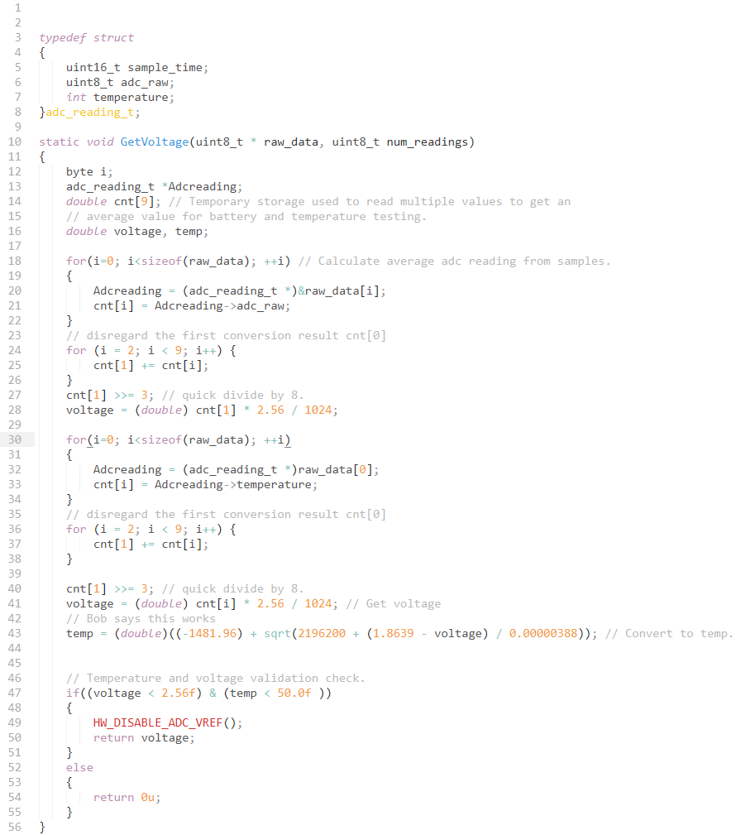

**1. Bug: line 12: no data type of “byte”, should be “int i”**

**2. Potential bugs:**

**- line 32: should be “Adcreading = (adc_reading_t *)&raw_data[i];”.**

**- “num_readings” was declared but not used.**

**3. Bad practice:**

**- It is unclear why have repetitive calculation of voltage in line 28 and 41. It might be 2 different voltages of battery and temperature sensor, if it is the case then the variable name should be different for clarification.**

**- Indentation and position of comment were not consistent.**

**4. Recommendations:**

**- The 2 for loop to calculate average value of voltage and temperature is similar and could be combined.**

**- Comment should better describe the meaning/purpose of function/procedure.**

**Section 2: Problem Solving and Implementation**

1. Using either C or C++, implement and test a circular buffer (ring buffer). Additional files may be submitted along with this test. The circular buffer must, at a minimum, perform a push, pull and init operations. It may work on a fixed data type and must function in a FIFO manner. Comment on design decisions (have you optimised for speed or space? Are your items allocated statically? Why?).

* **Please check the code in attached file (with the email).**

DO NOT CODE HERE.

**Section 3: Electronics**

1. Given BAT+ is 4.2V DC, determine the voltage (with reference to GND) at;
   1. ‘VBAT’ = **≈ 0.76V**
   2. ‘SYS’ = **2.5V**

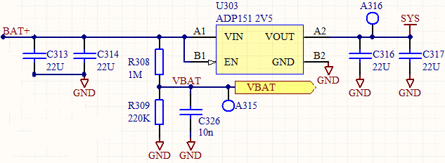

1. Given the circuit above, what considerations would you make when connecting VBAT to an ADC?

* **Even the DC output voltage of battery (VBAT) can be assumed as a low noise signal, but we could add a lowpass filter (RC or LC) to reduce any AC noise from other nearby components to interfere into the input of ADC.**
* **Because the VBAT create by the voltage divider has high output impedance so it should work well with ADC which also has high input impedance, otherwise you might need an impedance matching circuit (buffer) for a low input impedance ADC.**